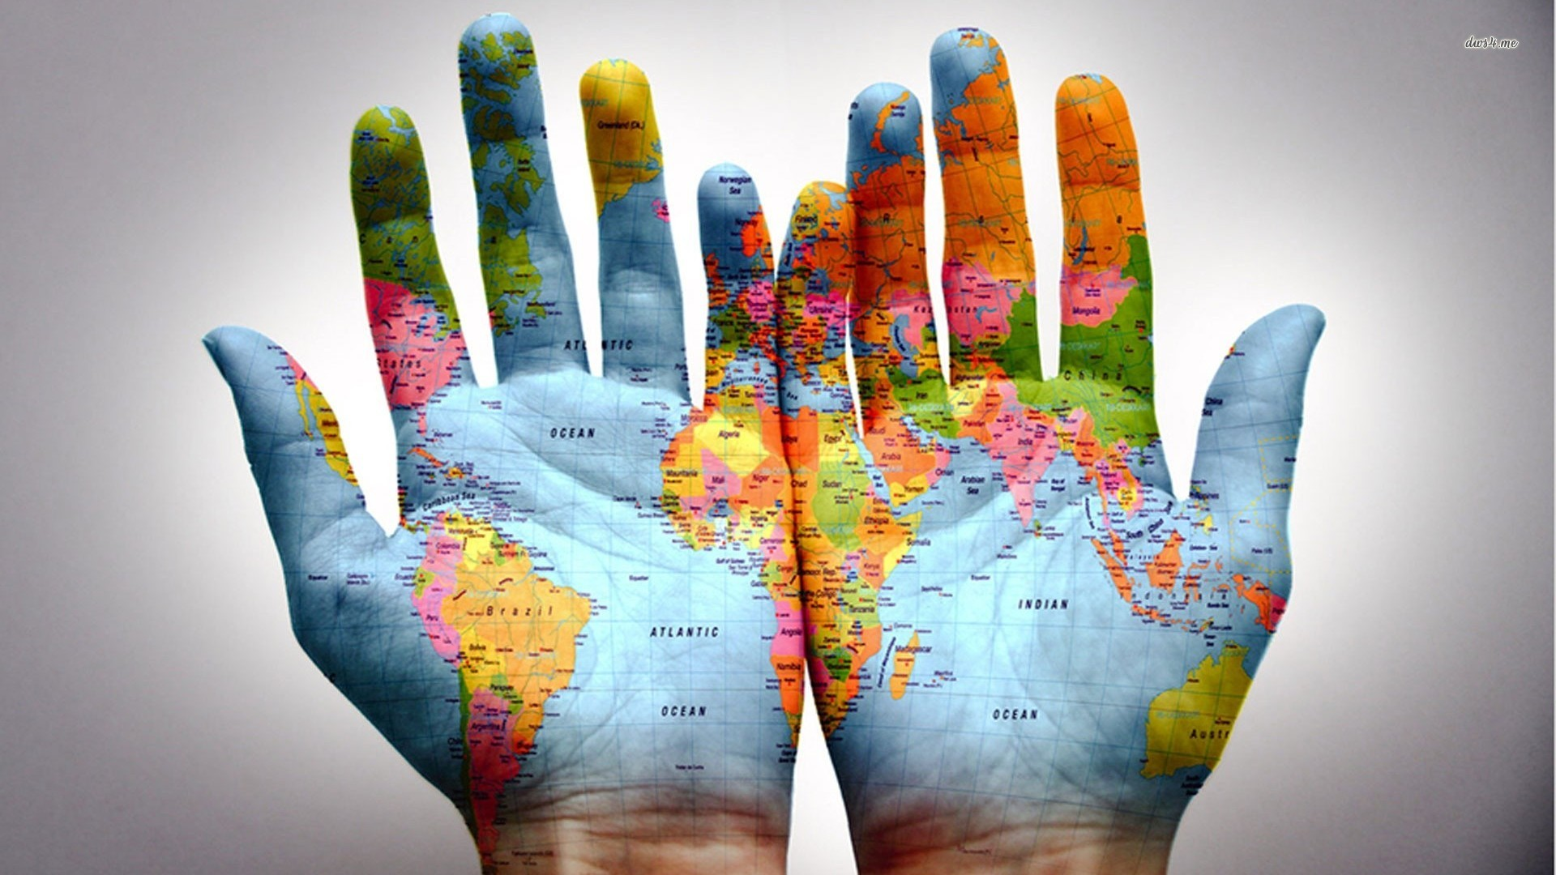

## Ms. Roxy McKnight

## My Contact Information-

**Digital Portfolio:**

[rmdp.weebly.com](http://rmdp.weebly.com)

**Email:** [roxy.mcknight@animashighschool.com](mailto:mcknightroxanne@gmail.com)

**Phone Number:**

970-247-2474 (High School Main Office)

**Office Hours:** THURSDAY

3:30 - 4:30 PM

*Or by arranged appointment

2

**Advanced Digital Art:**

Course for students that have already taken Digital Art at Animas High School OR have a strong understanding of computer technologies.

1

**Digital Art:**

Course for students that have never taken Digital Art at Animas High School

Course Differences:

Art has the ability to transform lives.

Digital Art @ AHS

It’s a fresh, integrated approach to learning the Digital Arts

FALL 2015

Fall 2015



All Projects will be graded based on content skills acquired, the ability to meet deadlines, published updates on Digital Portfolios, in addition to personal growth assessed from ongoing feedback conversations between the student and myself. To encourage you to take ownership of your own grades, I ask that you please contact me directly with any questions about your assignments and grades.  Please ***do not*** have your parents contact me regarding your grades ***until*** you have asked the questions first, via email, speech, or writing.  If you or your parents still have questions after you have talked to me, I would be happy to address your/their concerns then.

**WHO:**

* **“Freshpeople” and**
* **other students new to AHS that did not have DA as a 9th grader**

### Grading Scale:

### Some Essential Questions:

### Digital Art Course Overview:

Digital Art

Technology changes so quickly today that students no longer can simply memorize programs and their operating systems, especially in our 21st Century Project Based Learning Environment. In this Digital Art class you will gain skills to think through challenging technology projects by critically analyzing problems, creating and designing original visual representations both independently and collaboratively.  To develop these skills, you will become familiar with complex programs such as but not limited to:

* Photoshop/Illustrator
* Dreamweaver / Weebly
* Adobe Flash
* Various Movie Editing Programs

1. What are ways to analyze and discuss works of art?

2. How do various cultures experience and define art?

3. Why would context matter when interpreting art?

4. **What is the purpose of art**?

5. How can art make important contributions to society?

6. Why do artists produce preliminary plans?

Advanced Digital Art

Fall 2015

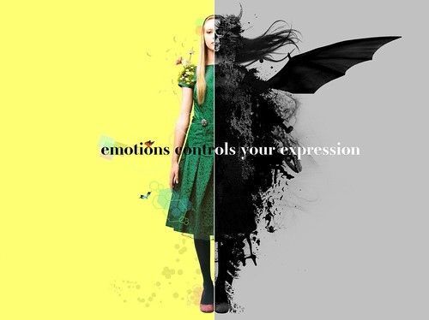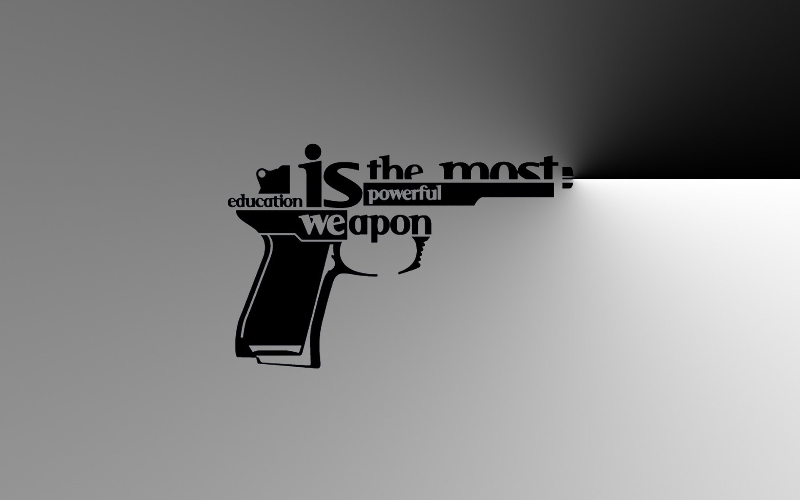

**WHO:**

* **Upperclasspeople**
* **Students that are serious about the Arts**
* Always show up to class, unless you have a pre-arranged absence.
* Volunteer as a Teacher’s Assistant once a week for the entire class period. This job will sometimes entail that you help answer questions from your peers, other times it will provide you the opportunity to lead a class discussion or lesson.
* Create a brand for yourself over the semester or year that you will turn into a sticker.
* Complete 1-3 highly refined, professional works of art for the end of the year Upperclassmen Art Show.

##### Required Elements of this Experience:

**2015/2016 Piloted Integrated Digital Art Program**: Integrate all students of different ages and with various computer skills to explore the evolving digital technologies collaboratively, in a supportive, 21st Century teaching and learning environment.

***My Graduate Research Data collected from AHS Upperclassmen found:***

Differentiation in the Digital Arts must be well supported.

Student Voice and Choice is a vital part in maintaining a “Culture of Excellence” at our school.

Expansion of student body and interests requires additions in both the Studio and Digital Arts.

* Students desire a class dedicated to creativity and problem solving and feel Digital Art fits this need.
* Students want to contribute to their culture of excellence by raising the bar for others while collaborating in a structured and supportive environment.

##### Why the Change?

Rules:

Requirements:

Policies & Norms:

Materials:

**Headphones**

*\*Must bring to class everyday, as we may need them randomly.*

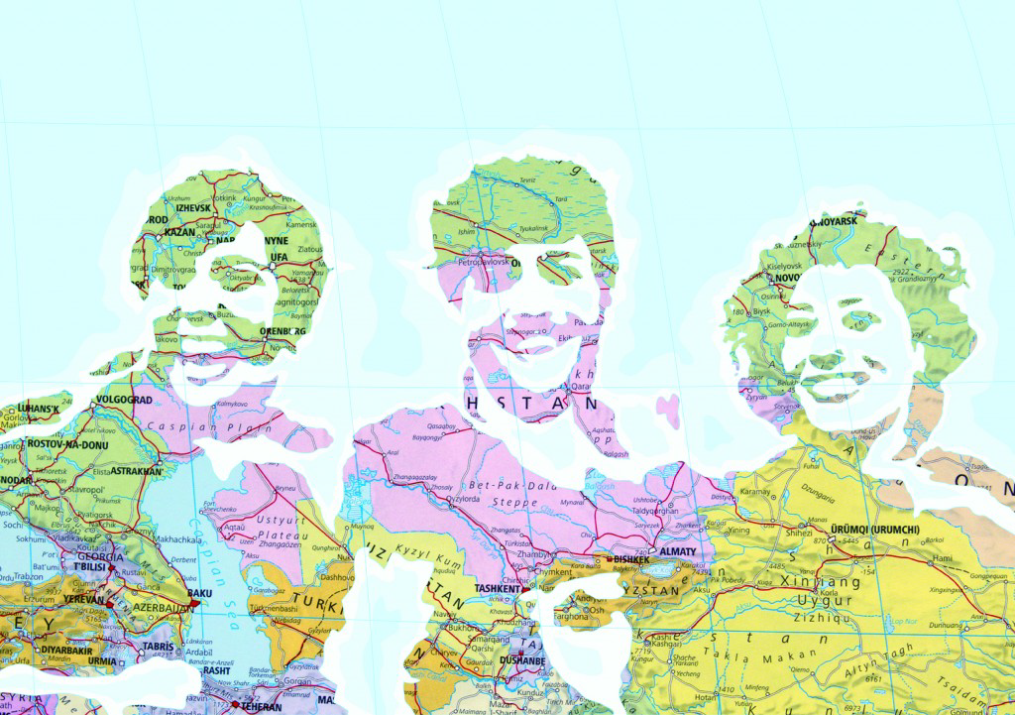

*As a Digital Citizen, it is not a question of your individual rights but of your responsibilities as a global community member.*

1. **Don’t scroll your life away.**
2. **Be willing to broaden your perspectives.**
3. **Practice kindness in all of your interactions.**
4. **Treat the exercise balls with respect.**

*\* Violation of these Digital Art Lab policies and norms could result in removal from the class.*

**USB Drive**

*SIZE-*

16 – 32 GB Minimum

Student Signature: __________________________________

Parent/Gaurdian(s): _________________________________

**Sketchbook**

*\*Must be bound so that it doesn’t tare or lose pages.*

*\*\*\*Please see me ASAP if obtaining these materials is going to be an issue*