Skill/Knowledge | Exemplary | Proficient | Basic | Novice
Creativity | I consistently show flexibility and originality.  I produce many new ideas and ways to do things. | I am generally able to demonstrate and apply components of creativity in the course of a project. | I try to think creatively but sometimes needs help coming up with new ideas. | With support, I can generate some creative ideas.
Design | My design is truly multimedia rather than linear & includes a number of well-designed objects and elements. | My design contained some appropriate objects and elements to support my purpose. | I can make few choices of objects and elements, thus compromising the quality and relevance of my work. | My design is limited in several ways, i.e. it isn’t digitally enhanced or accessible on the web.
Productivity  (Project Work Time) | I routinely coordinate time, effort, and resources to ensure the highest quality work. | I demonstrate appropriate use of resources results in a final product that meets requirements. | I sometimes forget to check time and pacing, which results in incomplete work. | I need support to select materials and use time appropriately.

Logo Design Project Objectives with Rubric
Student Objective: Study basic logo design techniques; illustrate multiple versions of unique logo creations, critique peer designs, refine logo based off of feedback from critique or individual choice, exhibit preliminary sketches, final versions and project reflections to global audience via digital portfolio.

_____ 1. Fill out this 21st Century skill and knowledge rubric accordingly:

_____ 2. Print off your 8.5 X 11 logo layout sheet and attach it to this rubric after you fill it out.

_____ 3. Based on my 21st skills outcome, checklist on the following page, and the refined logo product, I believe I should receive a(n):

Incomplete Grade | Completed Project Grade

CHECKLIST for 2nd Part of this project:
_________ 1. Put your logo on something (high resolution images ONLY folks!)

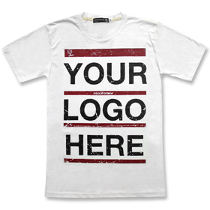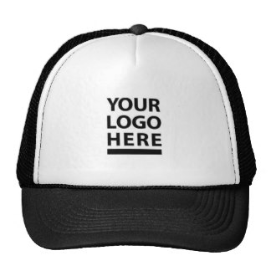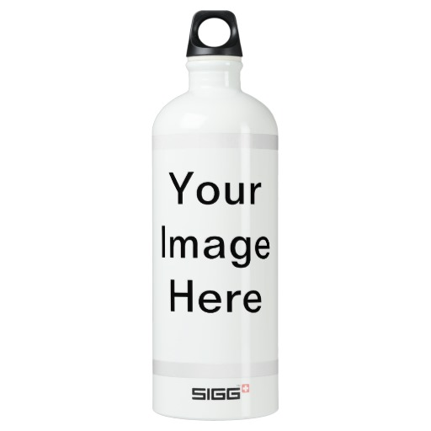

_________ 2. In Photoshop, copy all of your top choices onto a new 8.5 X 11 in. document (300 Res). This visual display of your work should be well balanced and communicate a clear message about what your logo represents.
Examples of top choices layout sheet:
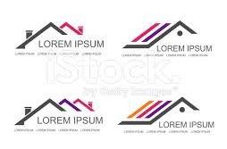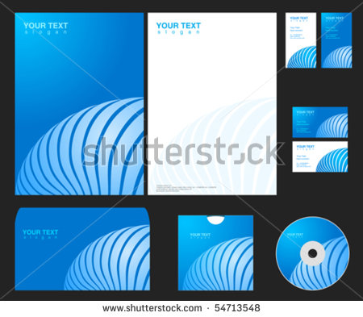

_________ 3. Print off layout sheet and attach to your rubric for project credit.

_________ 4. Update your DP according to the example on the example student digital portfolio. (remdp.weebly.com)

_________ 5. Extra time? In Illustrator use the pen, pencil, and brush tools to trace a favorite family photo. Try different stroke sizes and various fill hues for more realistic results.

